**DBMS - Group Project**

**Relational Model**

**Group Members:** Keerat Singh (2023282), Harsh Sharma (2023233), Ryan Bhan(2023452), Sanchay Singh (2023478)

**Submitted ER Model:**

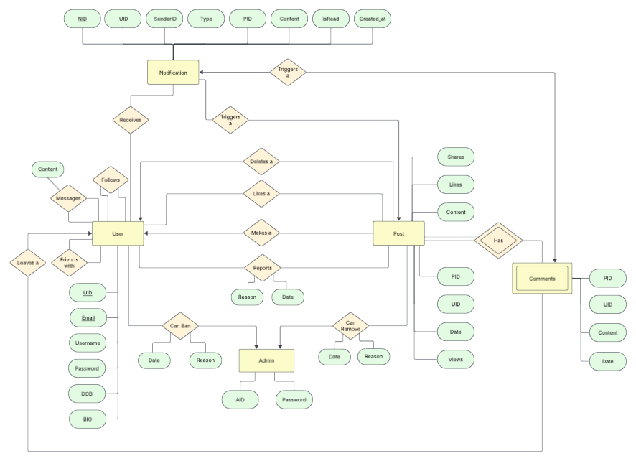

**Link:** <https://lucid.app/lucidchart/58f8eac4-947b-41fd-aa6f-753ca00f70d7/edit?viewport_loc=259%2C544%2C2523%2C1258%2C0_0&invitationId=inv_01275d8e-3a0c-4aff-ba78-9e1e05dfe936>

**Relational Schemas Derived:**

Users(UID, Username, Email, Password, DOB, Bio);

Posts(PID, Content, Date, Views, Likes, Shares, UID {fk})

Admins(AID, Password)

Currently_Banned(Date, Reason, UID {fk}, AID {fk})

Removed_Posts(AID {fk}, PID {fk}, Reason, Date)

COMMENTS(Date, Content, UID {fk}, PID {fk})

Follows(UID1 {fk},UID2 {fk})

Friends(UID1 {fk},UID2 {fk})

Messages(UID1 {fk}, UID2 {fk}, Content, Date)

Notification(NID, UID {fk}, SID {fk}, Type, PID {fk}, Content, isRead, Created_at)

Likes(UID {fk}, PID {fk});

Reports(UID {fk}, PID {fk}, Reason, Date)

**Diagrammatic Representation:**

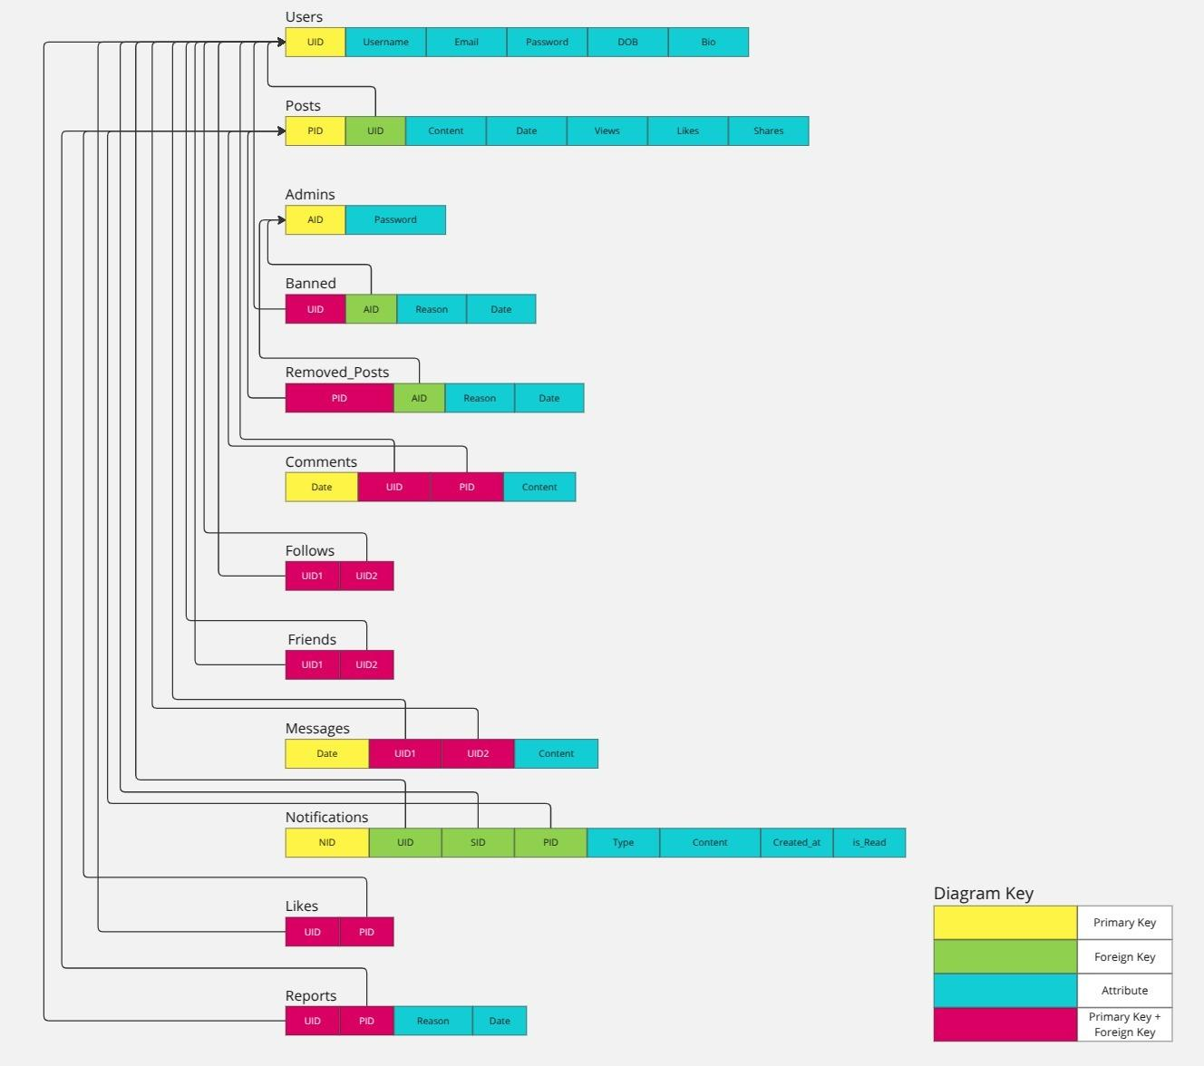

**Miro Link:**

[Miro](https://miro.com/app/board/uXjVIe_VltI=/?share_link_id=189201463424)